

**BEEE LAB EVALUATION 2**

**Name: Yash Chugh**

**Uid No: 19BCG1072**

**Branch: CSE (G and G)**

**Circuit Diagram:**

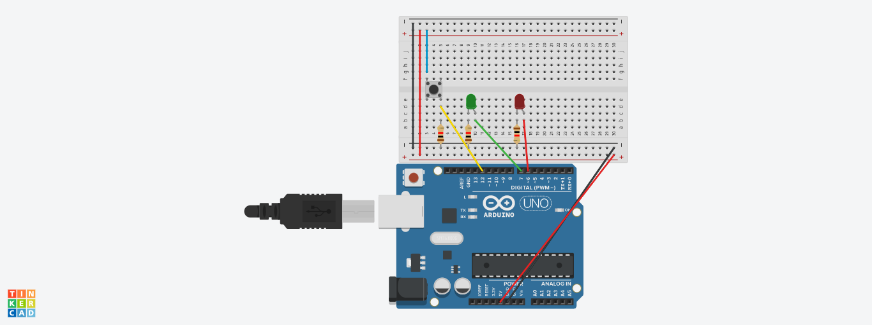

Concept used: In this experiment I used the concept of LED Flasher and a Switch case for completing my project.

**Learning and Observation**: I learn about the working of a smoking alarm from this experiment and carefully observed the connections of the circuit and how this can be made.

**Problems and troubleshooting:** In this experiment I found many many problems regarding the connections and code but I resolve problem through my previous knowledge of learning.

**Precautions:** I want to suggest that to take check of the connections that joint through the Aurdino and the breadboard and also check the code before running the experiment.

**Learning Outcomes:** I learn the working of smoking alarm and gas overflow system from this experiment.